Perception Armored

Team Members: Anthony, Calvin, Evan, Ro

Sprint 4 Review

**Proof of Work~**

* **Front-End Team**

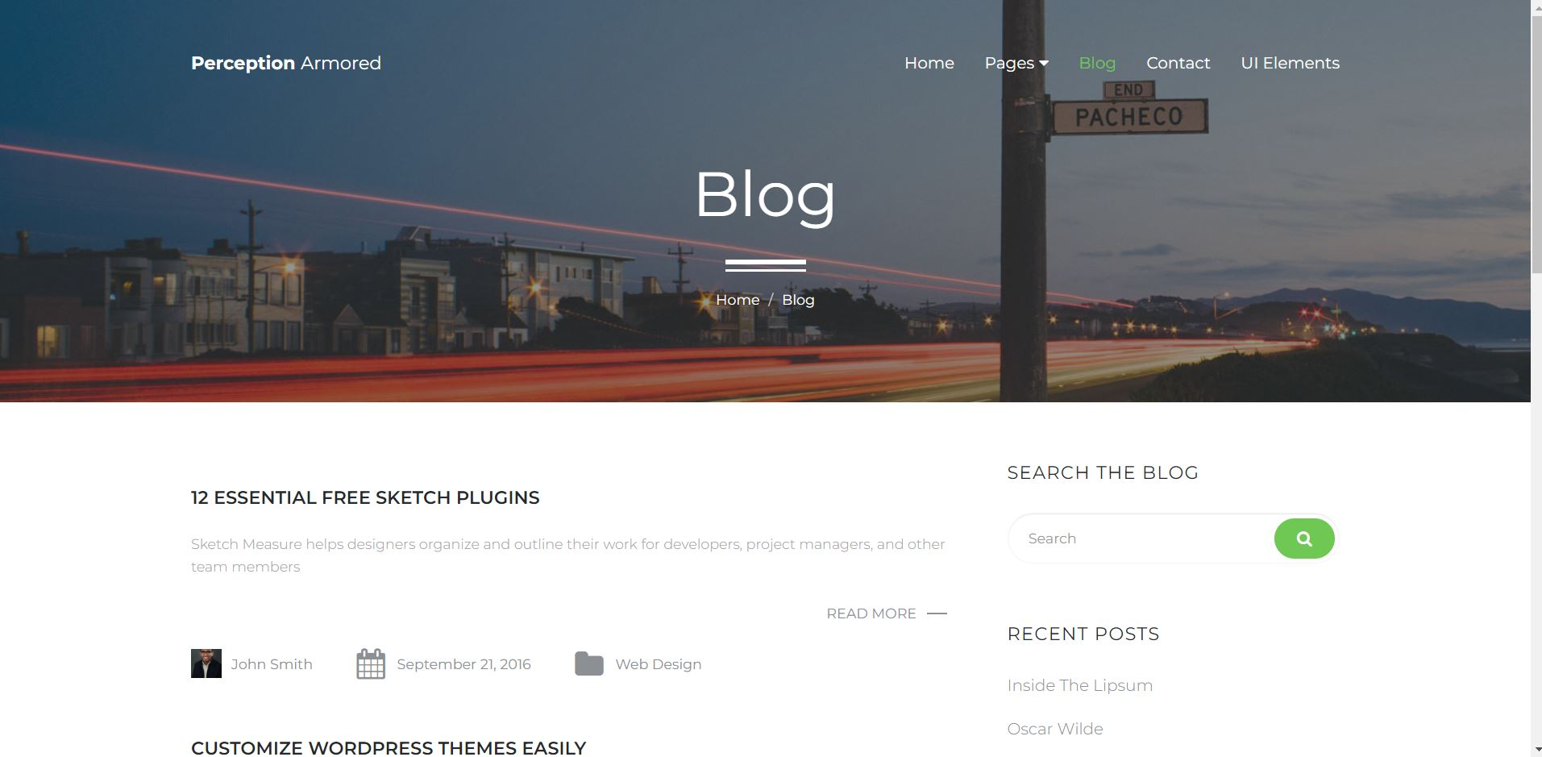

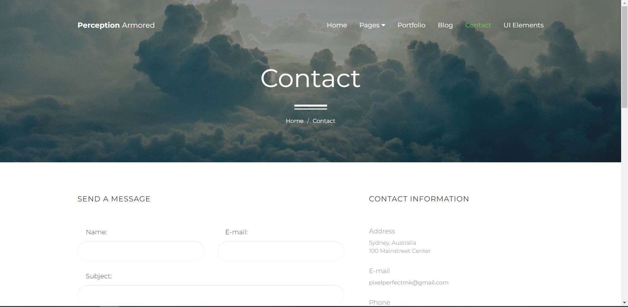

* **Back-End Team**

* **Report how the last Sprint went with regards to people**
  + Perception Armored Team
    - As Scrum Master I could have done a better job at communicating when files where ready to be submitted. I relied on verbal communication while I should have also utilized web-based communication as well.
    - There’s obviously gaps in professional experience, but that deficit is made up for in willingness to learn, grow and succeed
    - Our group members have grown to accept each other’s strengths and weaknesses.
* **Report how the last Sprint went with regards to Relationships**
  + Front-End Team
    - There was a bit of tension regarding the nesting problem caused by the front-end team.
    - Front-End team has grown closer through their UI collaboration.
  + Back-End Team
    - Back-end Team has grown closer through their teamwork and cooperation with discovering different back-end options .
* **Report how the last Sprint went with regards to Process**
  + Front-End Team
    - The dev process has become very rocky due to an ever-evolving nesting problem.
  + Back-End Team
    - Back-end Team has been continuously setting the bar very high in the development process and continues to do great work.
* **Report how the last Sprint went with regards to tools** 
  + Front-End Team
    - The front-end teams understanding of tools is continuing to grow slowly but steadily.
  + Back-End Team
    - Back-end Team has been researching new tools to aid in the dev process.
* **Major items identified and listed** 
  + Perception armored

Our communication has been very rocky as the school year winds down but we have not allowed that to create a negative work environment. We continue to stay positive and keep our heads up. Backend team has been helping the front-end team with the understanding of tools and that has definitely increased our productivity.

* **Improvements for next sprint**
* Make sure everyone is familiar with what is being posted on Trello. Make sure that internal communication remains positive and does not create a hostile work environment. Continue to grow our understanding of the tools we use in the project.